**MongoDB Lab 1**

**Part I – Installing MongoAtlas**

1. Navigate to: <https://www.mongodb.com/cloud/atlas>
2. Click **Get started free**:

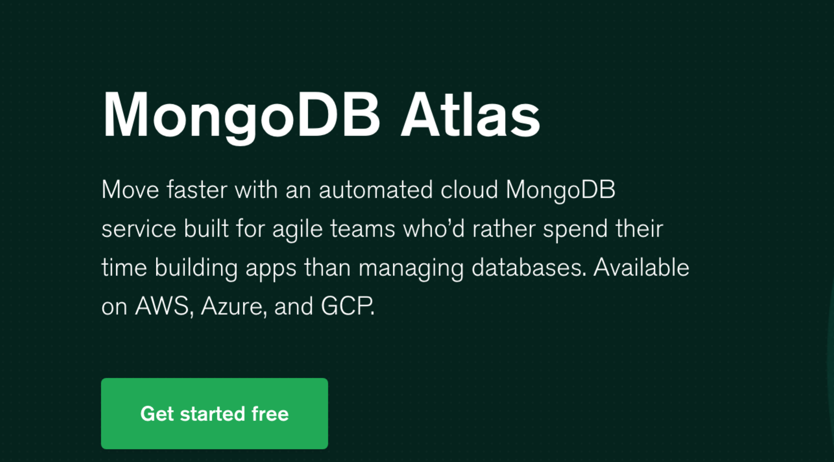

1. Fill out information on the left and deploy for free:

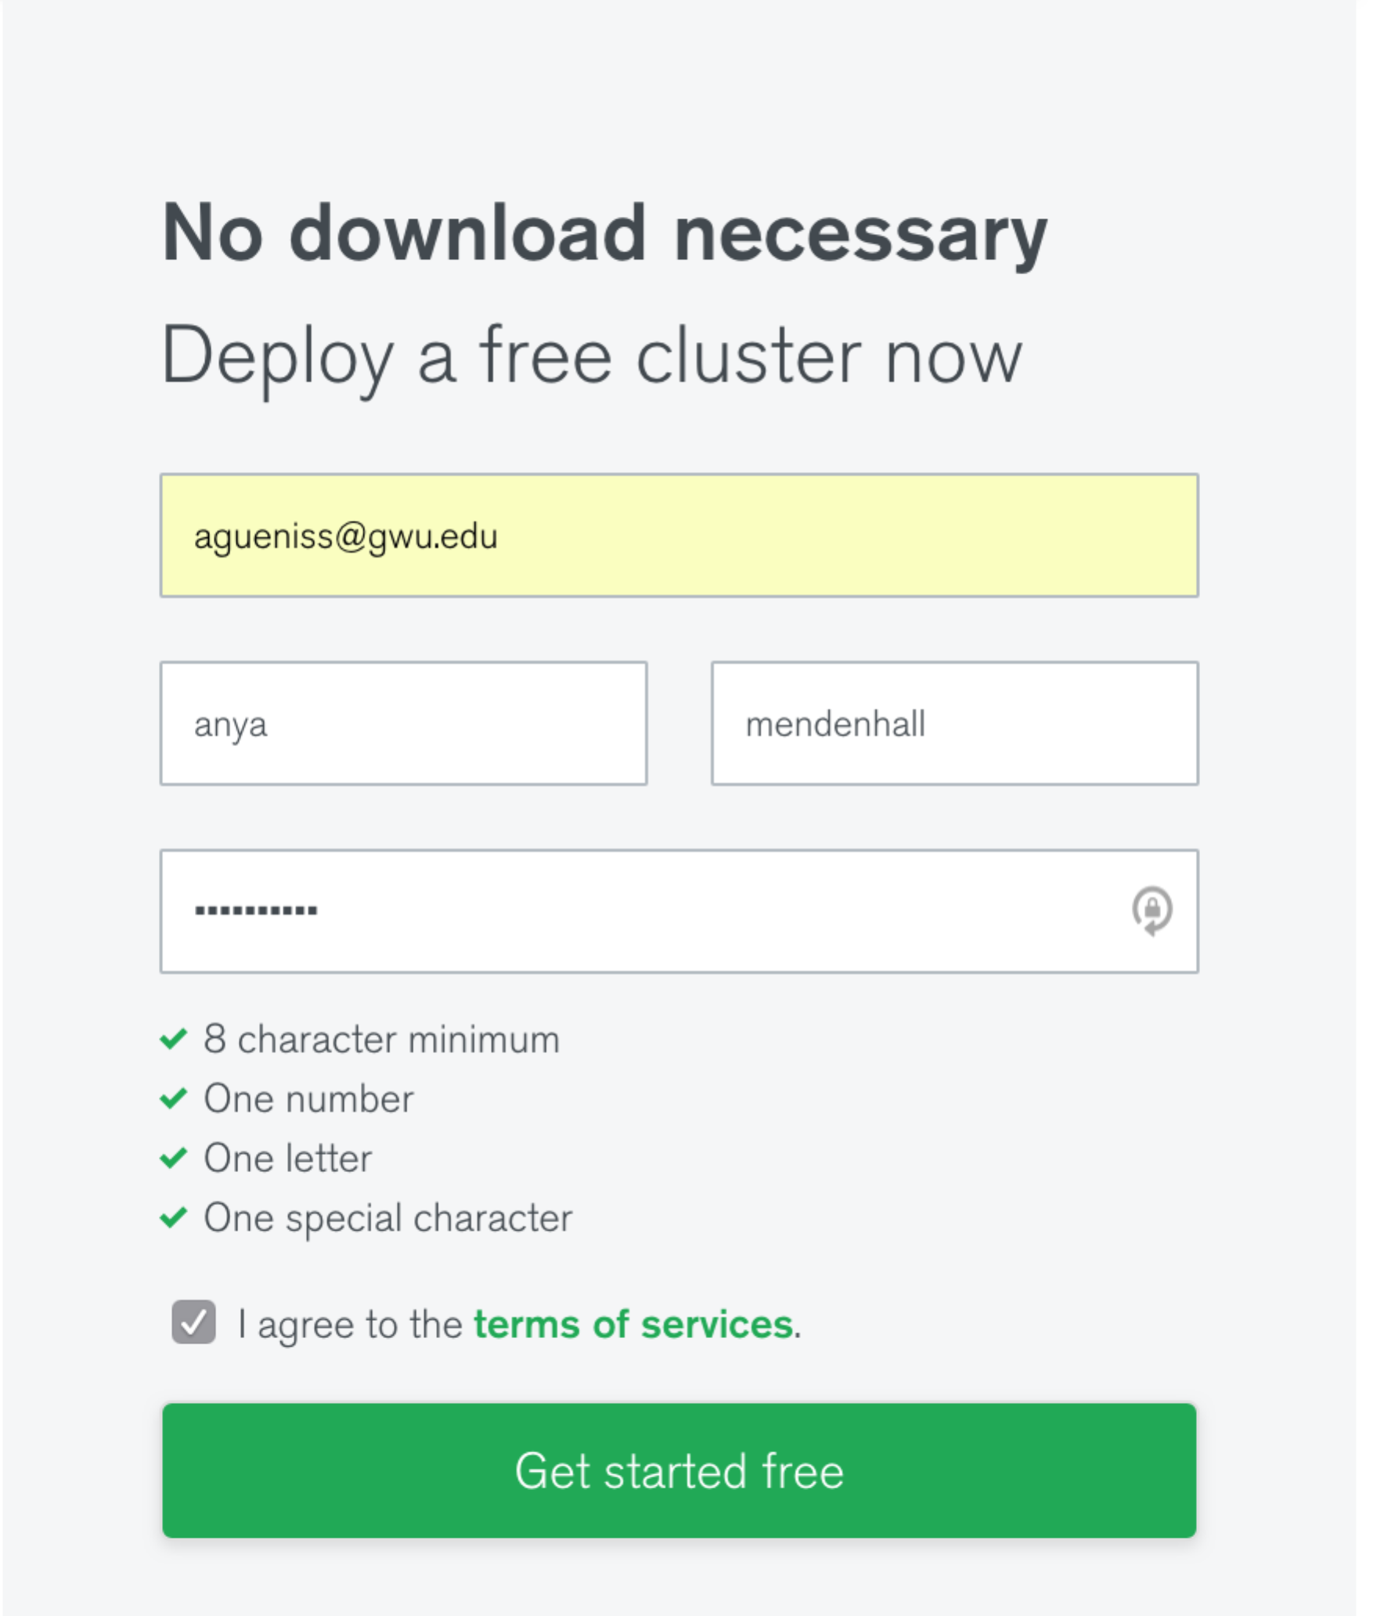

1. Click **Build my first cluster**

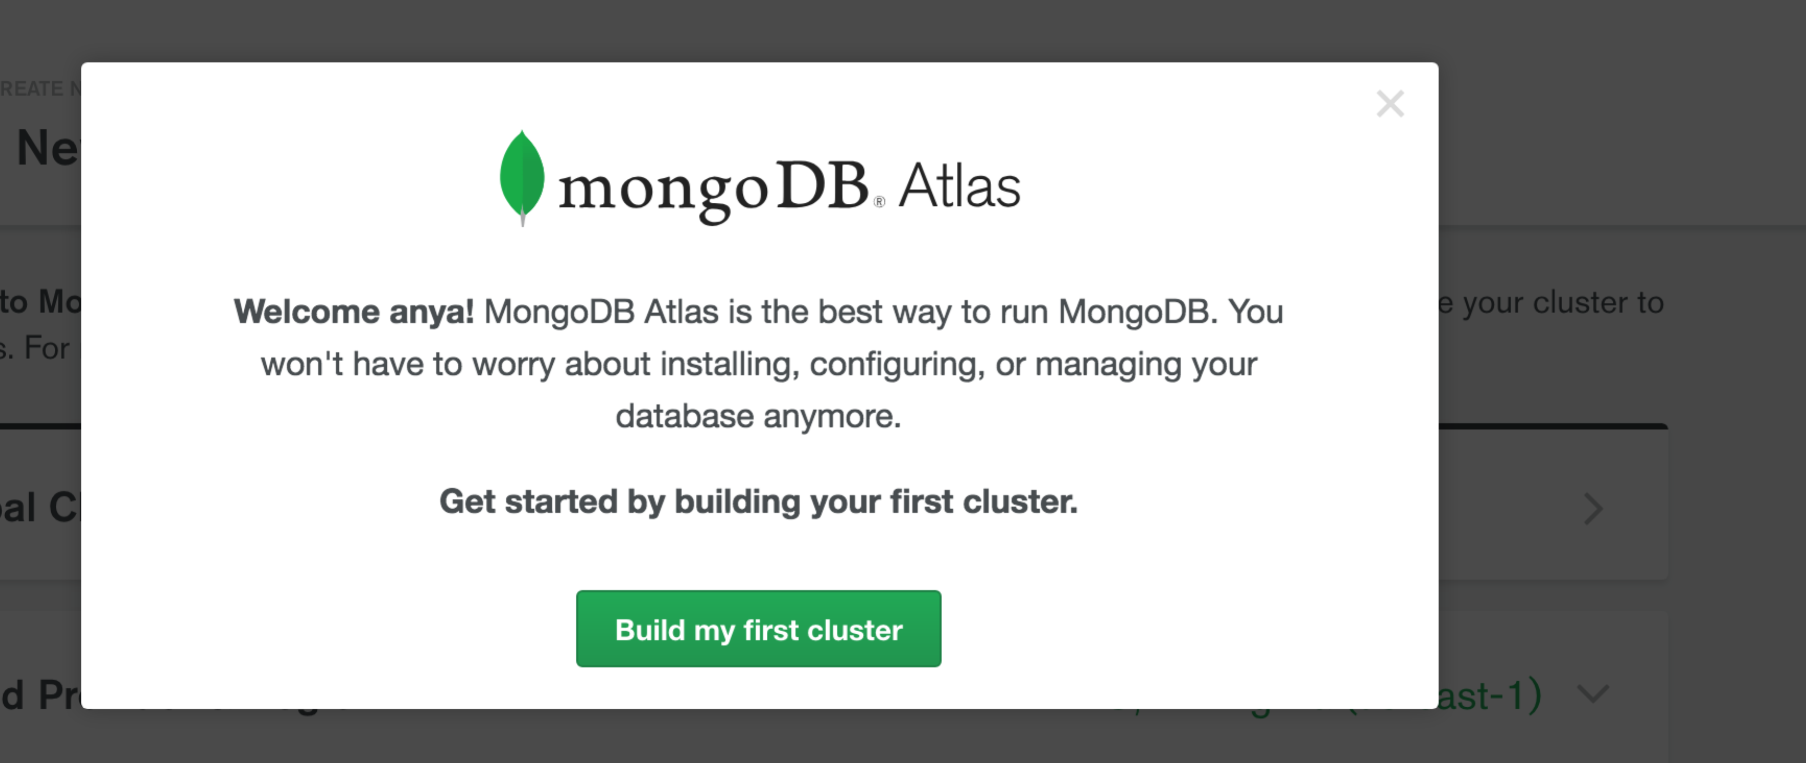

1. Chose AWS for cloud provider with Free Tier

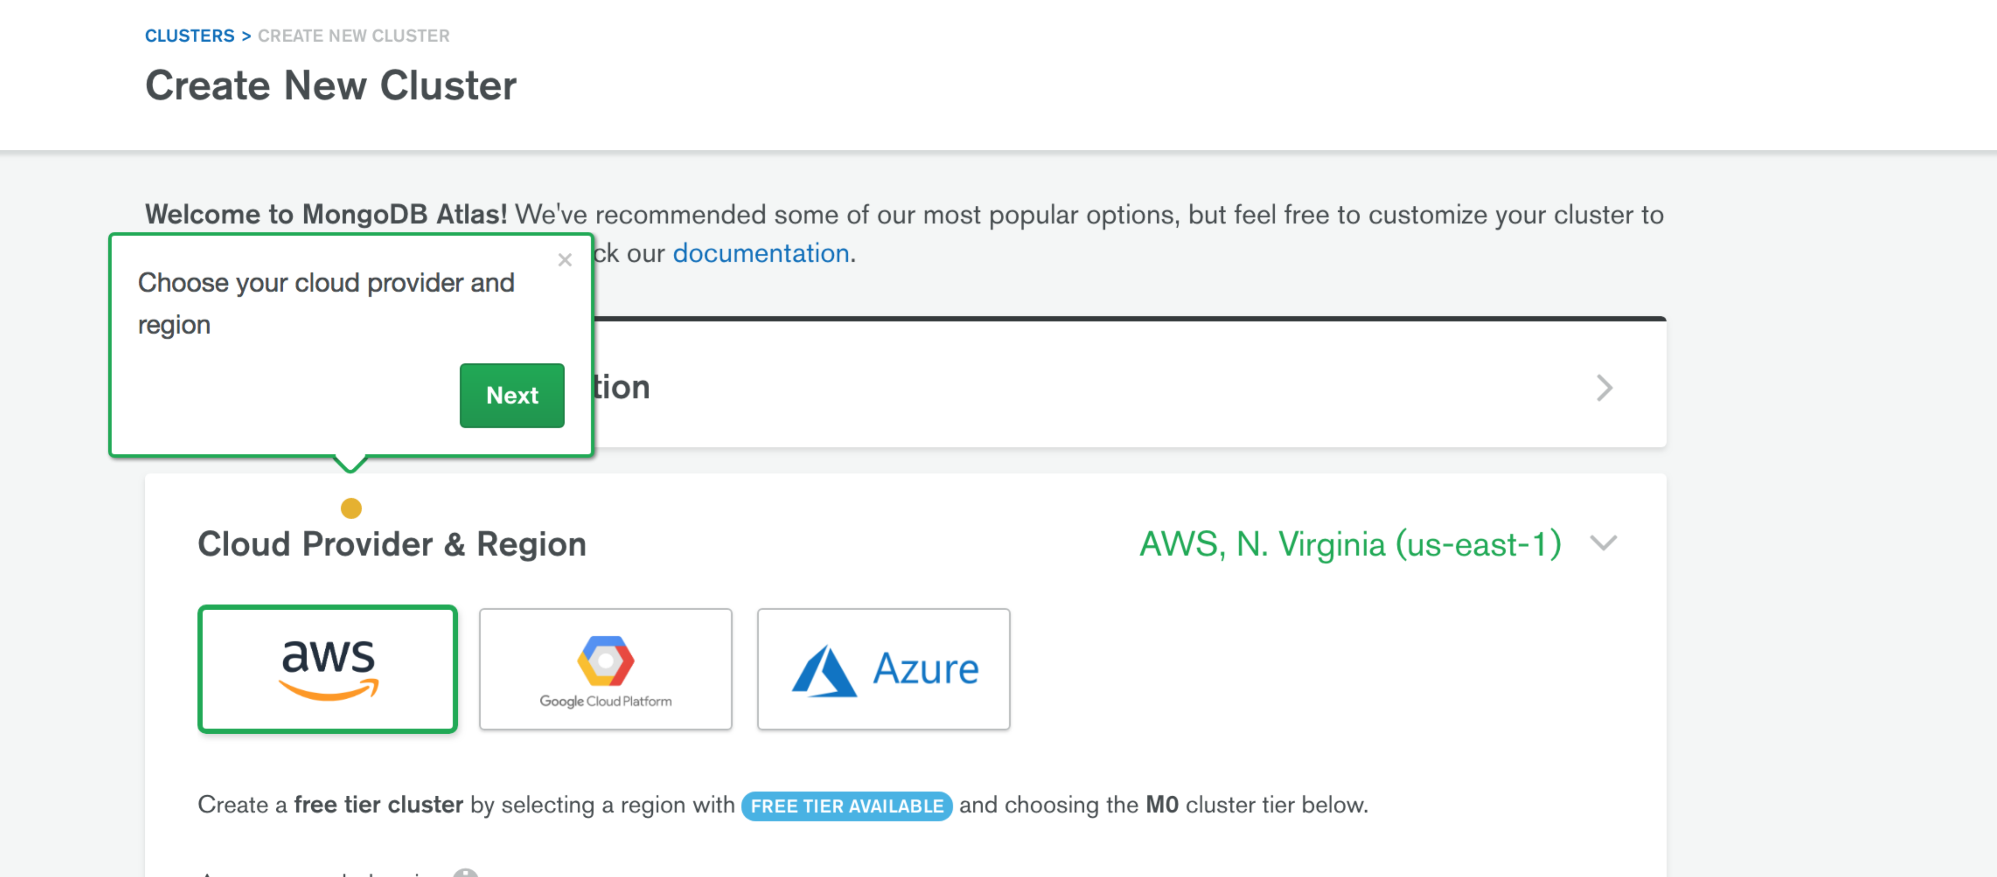

1. Click Create cluster (~10 minutes to provision)

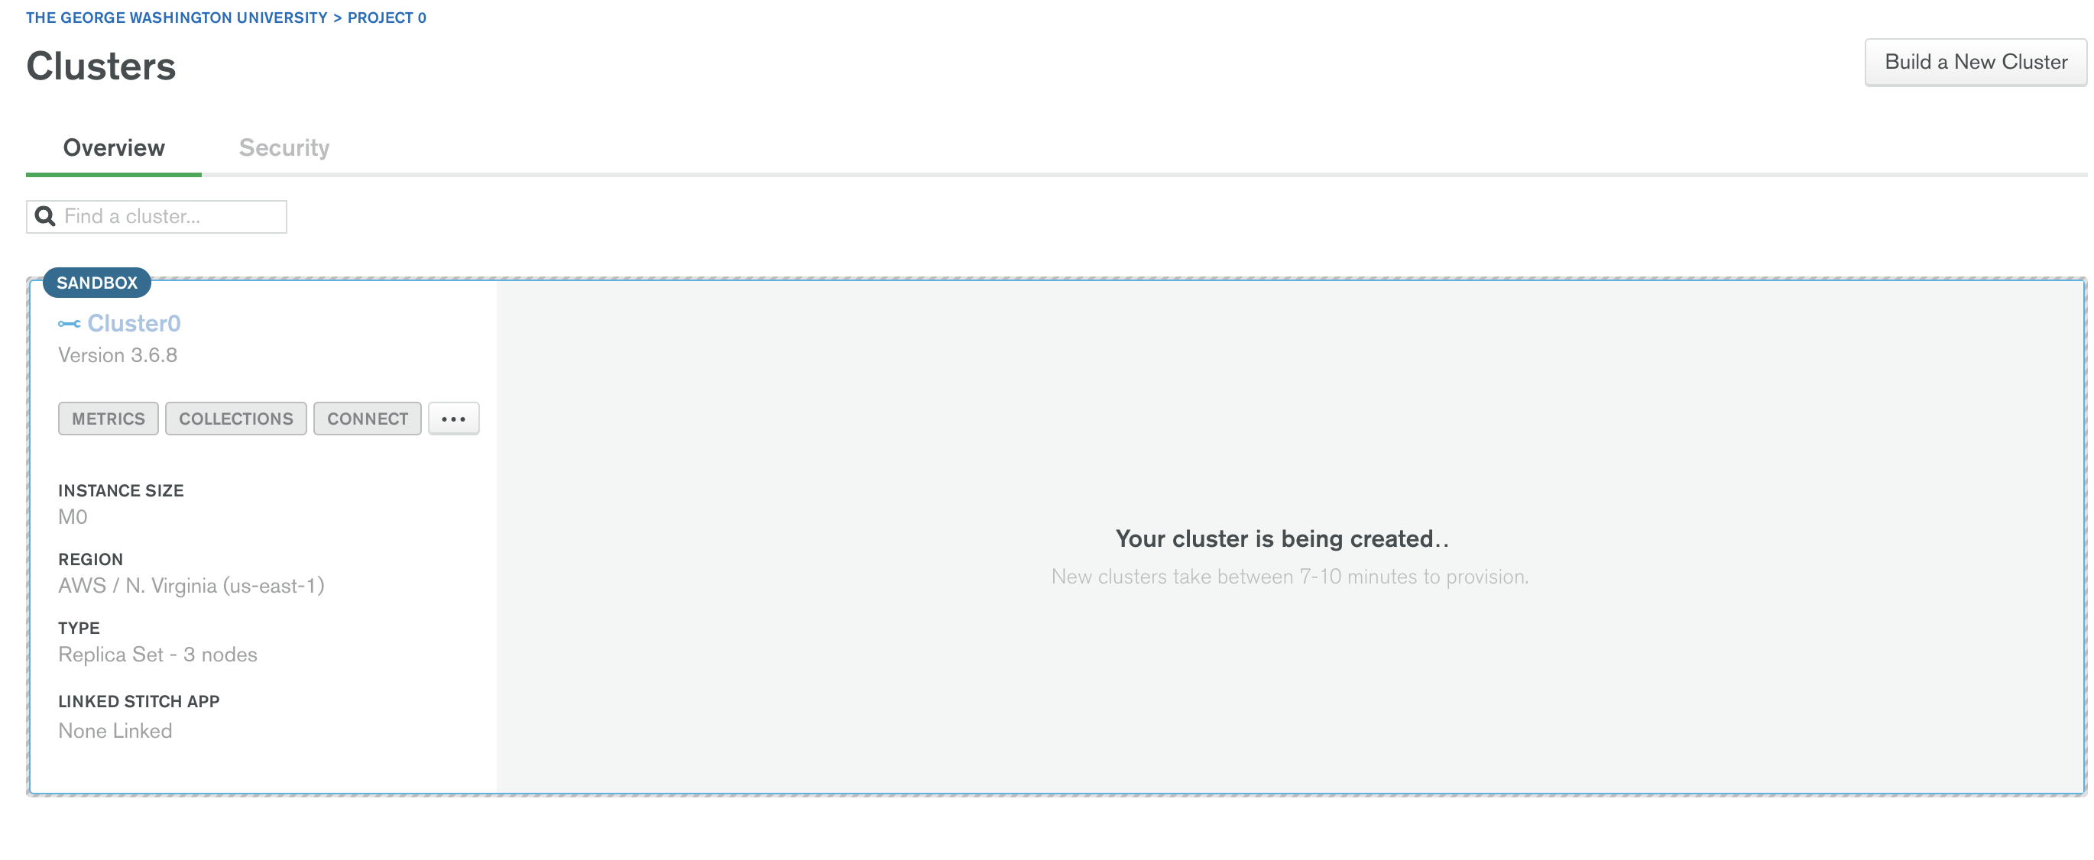

1. Go to Clusters 🡪 Security 🡪 Database Access (on the left):

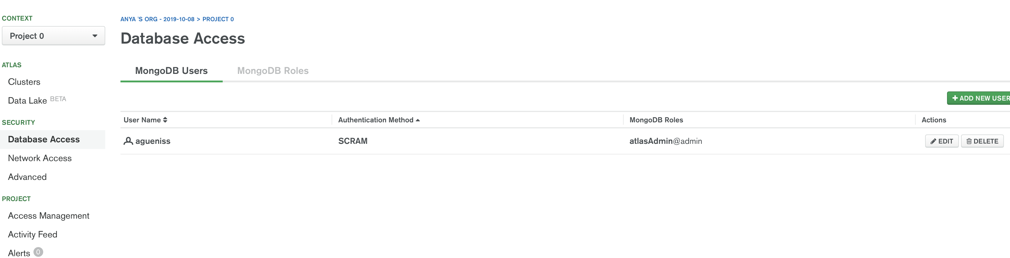

1. Click **Add New User** 🡪 Chose **Atlas Admin 🡪** Click **Add User (**use your netid and don’t forget the password)

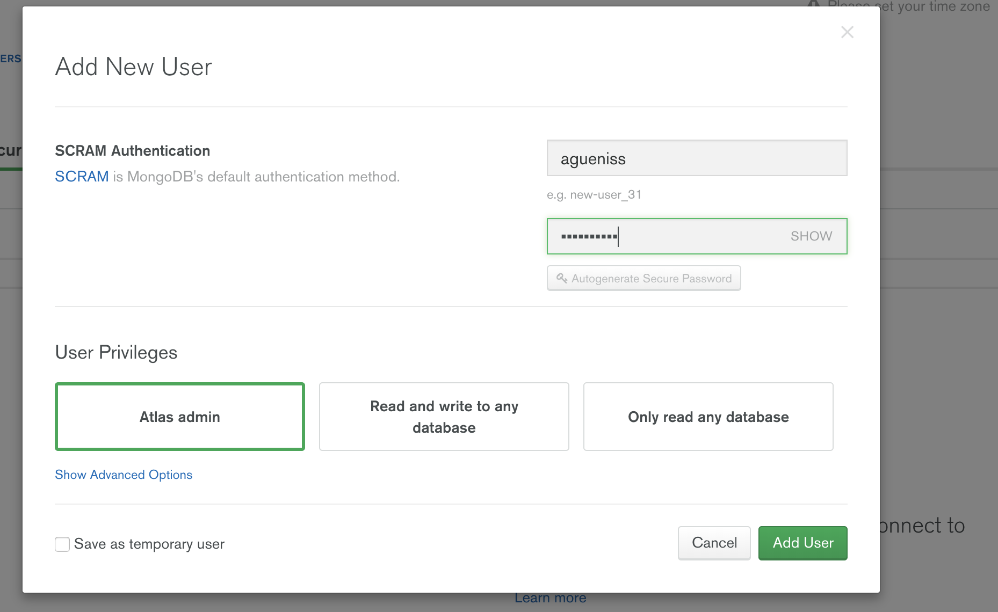

1. You should see newly created User as follows:

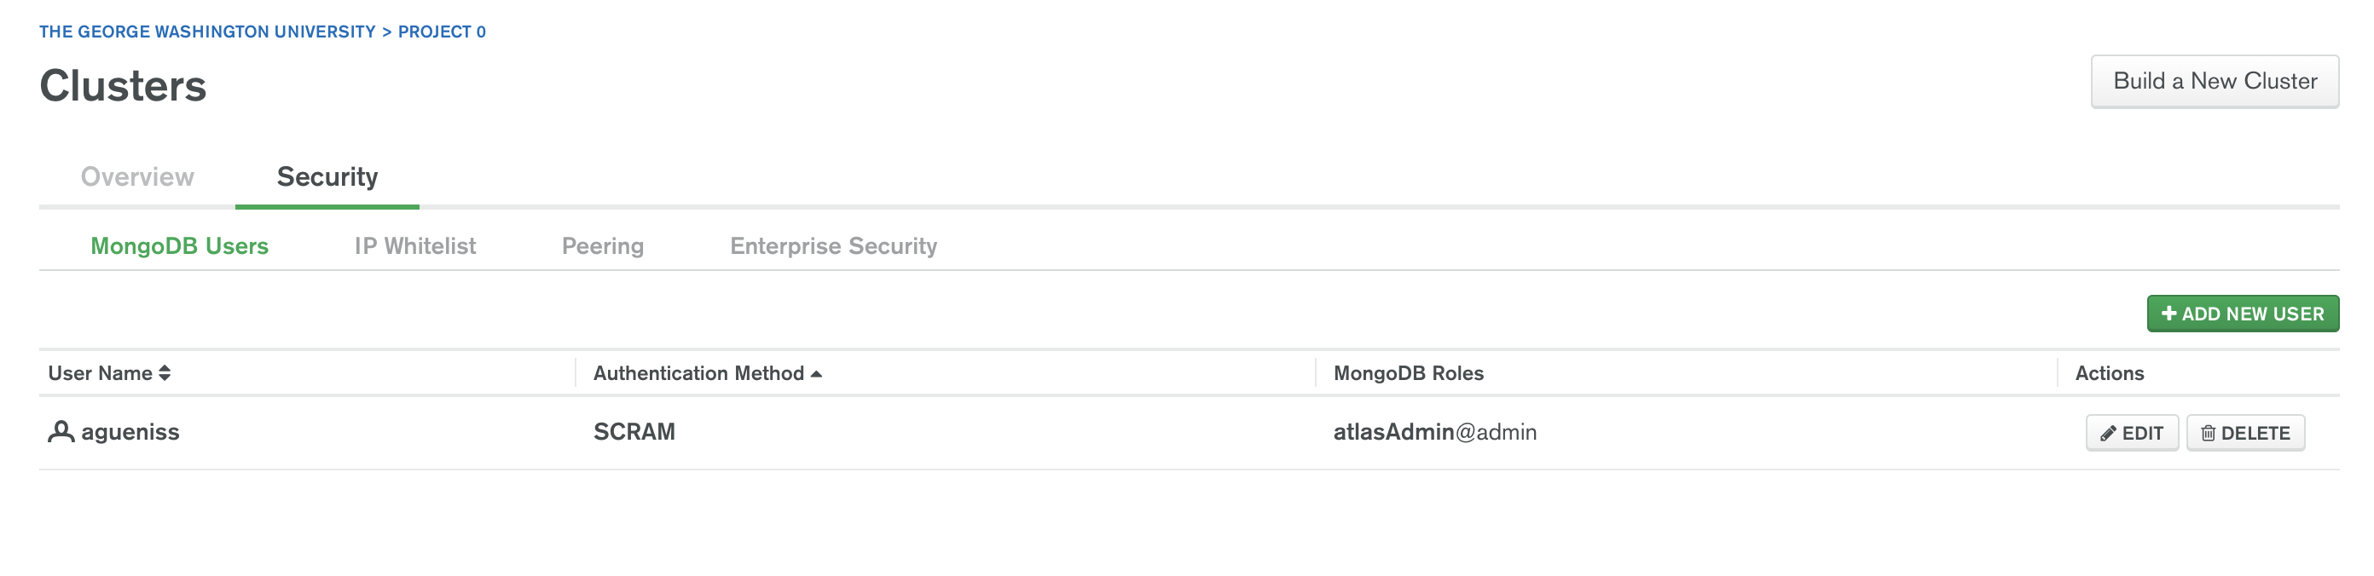

1. Cluster 🡪 Security 🡪 Network Access

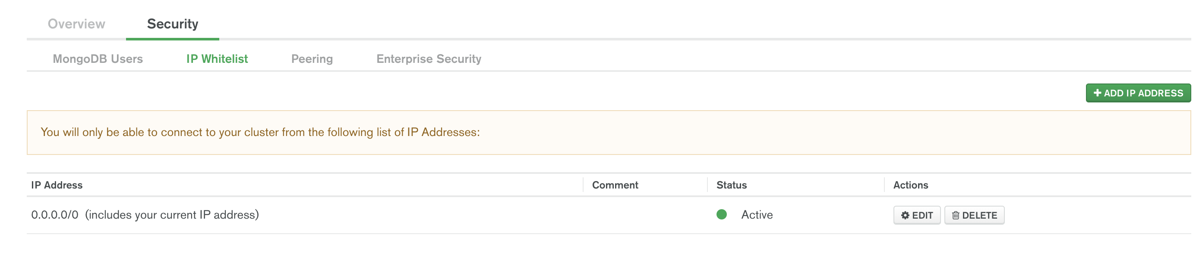

1. Click **Add IP Address** 🡪 Choose **Allow Access From Anywhere** 🡪 Click **Confirm**

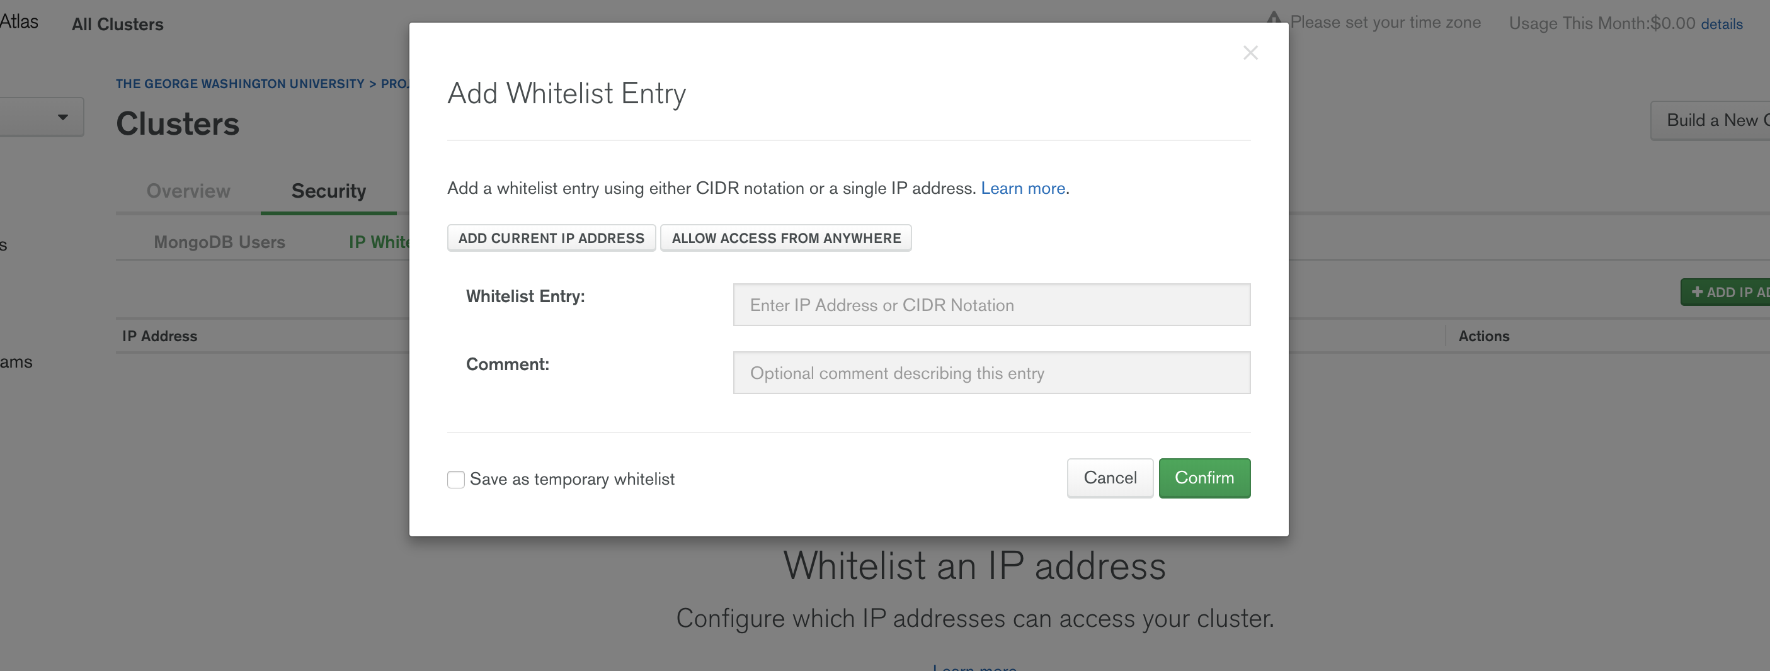

1. Allow access from anywhere 🡪 Confirm

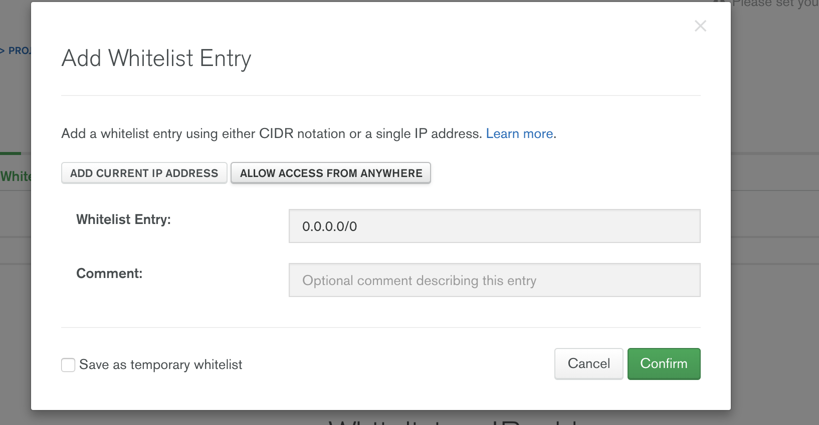

1. You will now see the following. Click on Project 0:

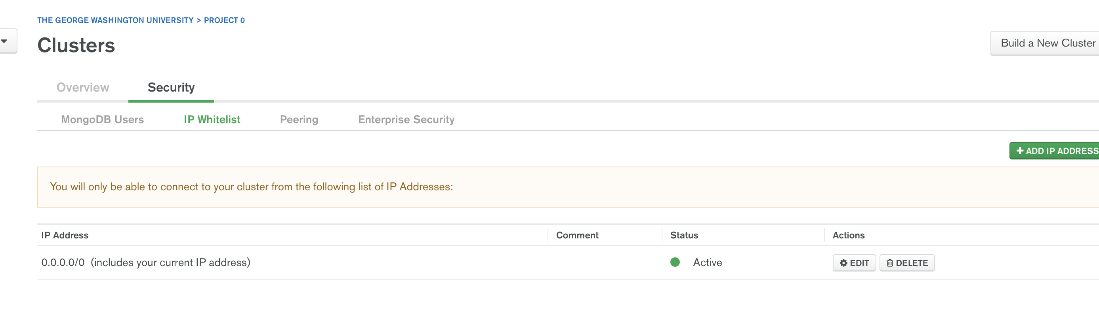

1. Click on Cluster0

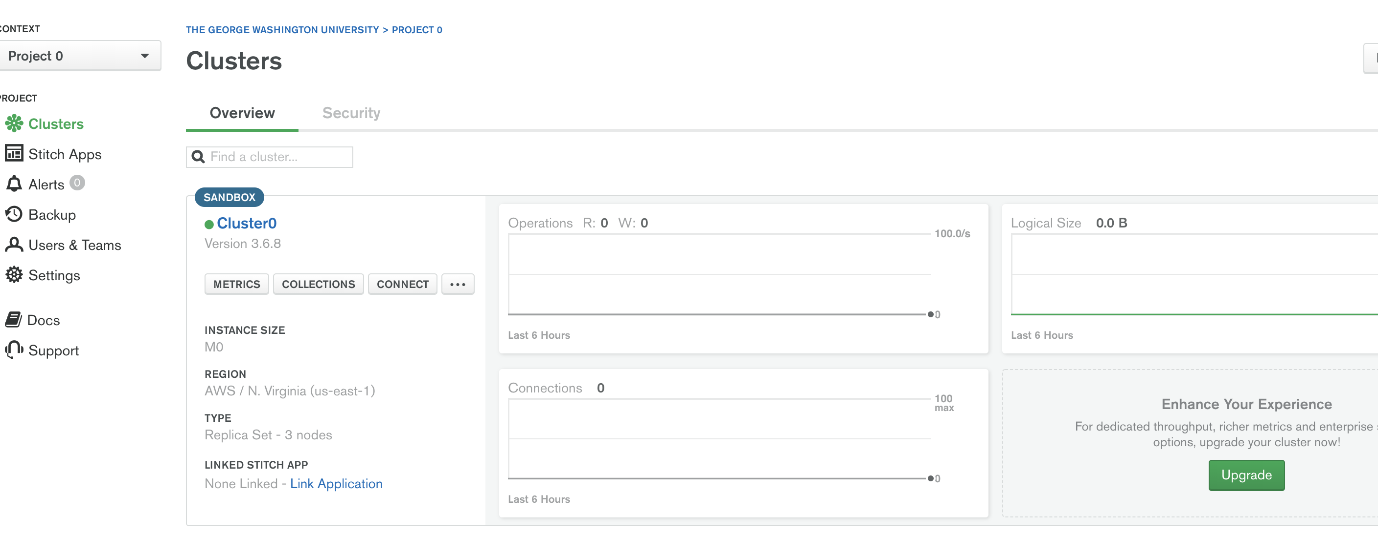

1. Click on Primary cluster as follows:

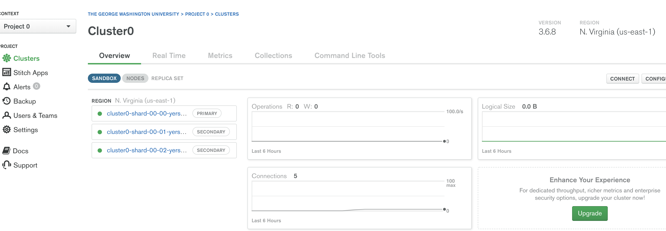

1. Observe cluster name on top copy it somewhere (**DO NOT COPY PORT 27017**):

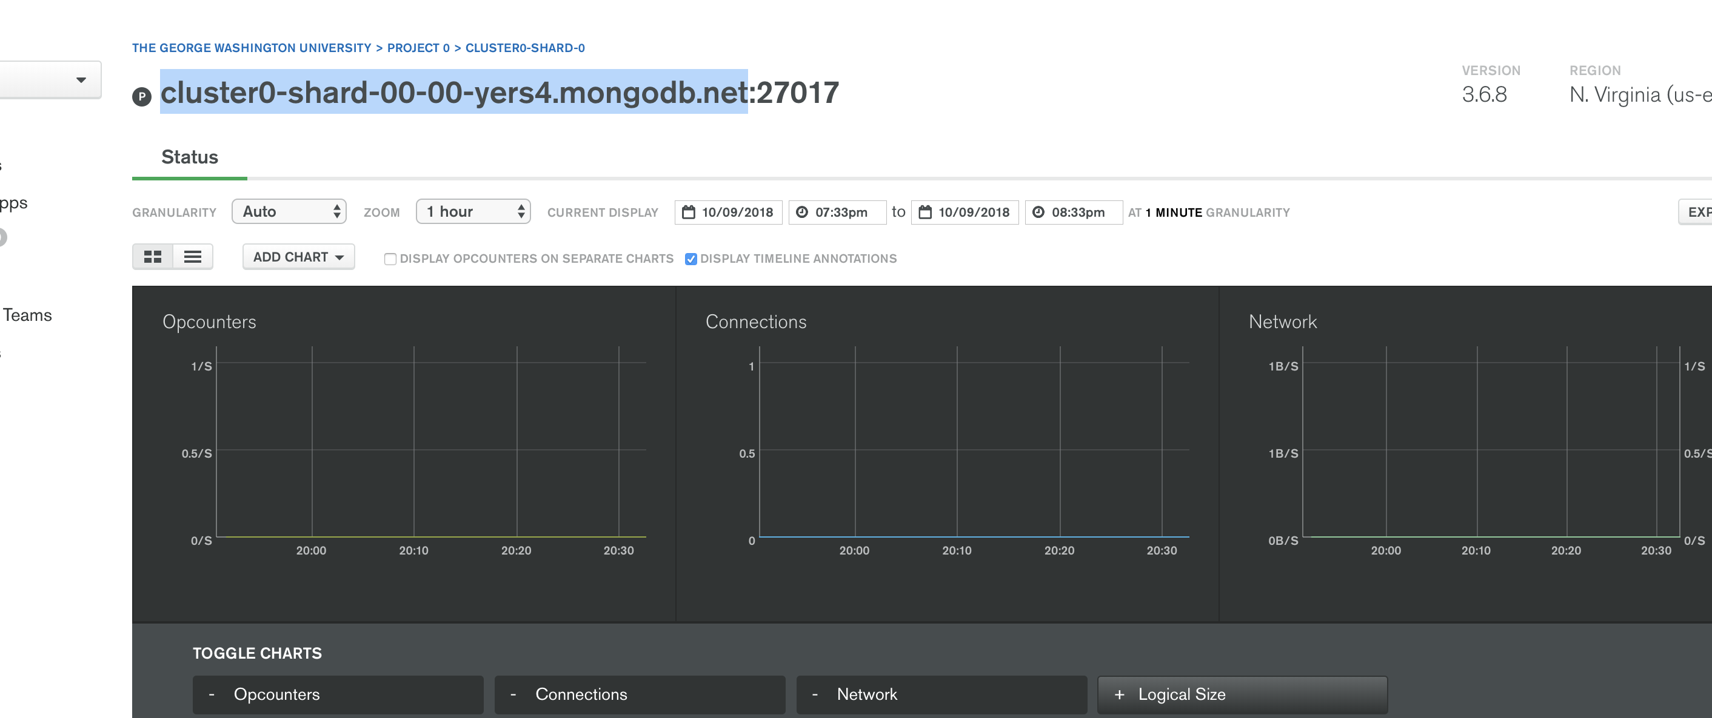

1. Go to download Studio 3T, you will use the cluster name copied above for it

**Part II – Installing Studio 3T**

1. Navigate to: <https://robomongo.org/download>
2. Download Studio 3T (on the left, **not Robo 3T)**

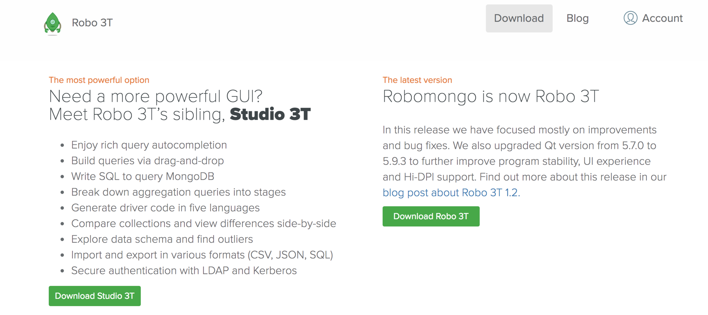

1. Open Studio 3T file, click to download and copy to Applications:

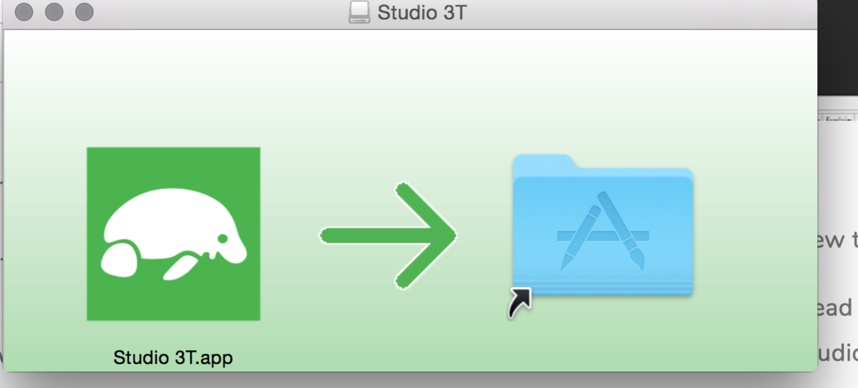

1. Leave everything default and click Finish

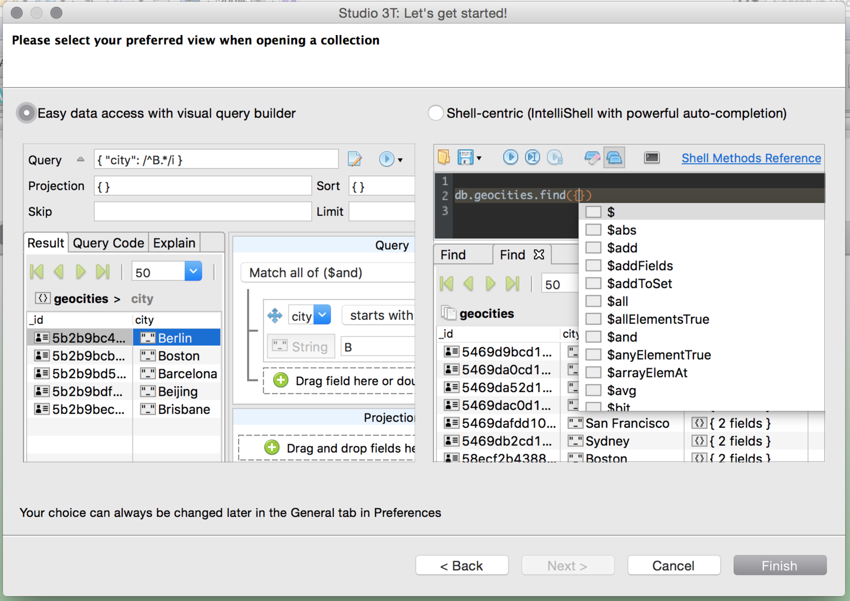

1. On the left click **Connect** to create New Connection

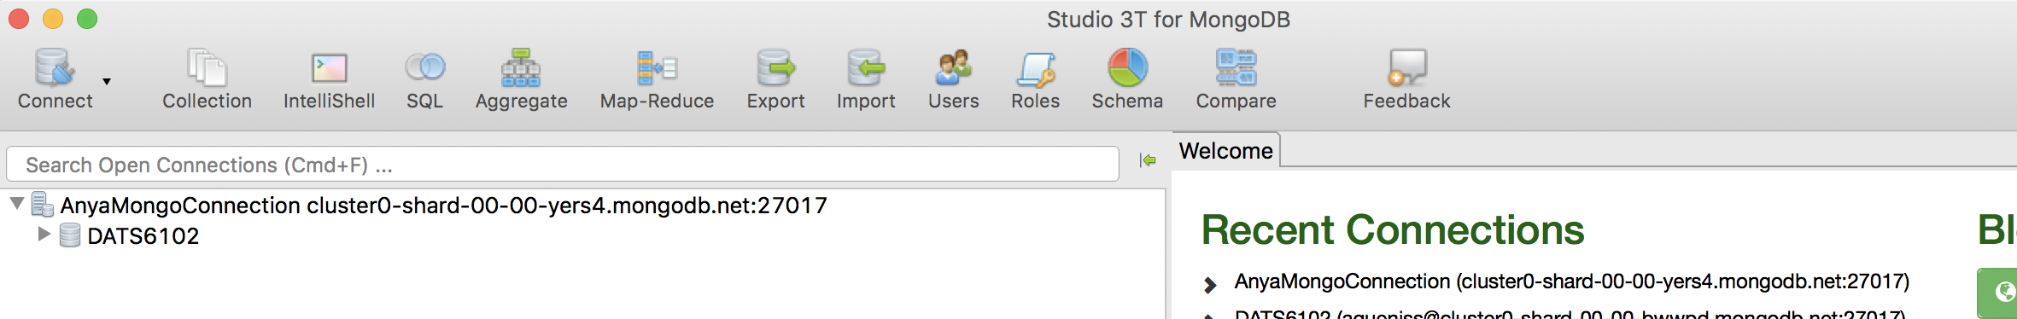

1. Click New Connection

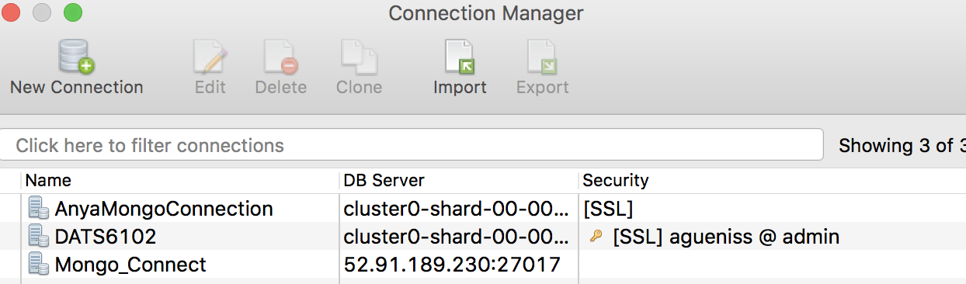

1. Enter the following:
   1. Name for your Connection (Mongo**YOURNETID**)
   2. Members – Add (**copy your mongoAtlas server name without port from Step 16 and you can remove localhost reference )**

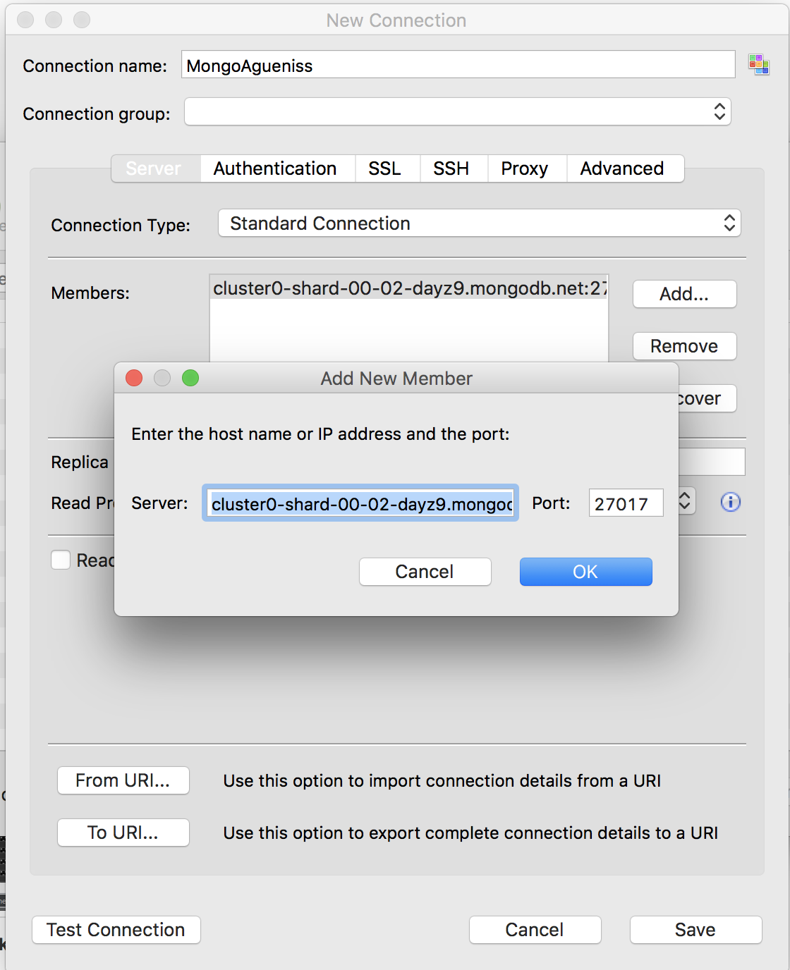

* 1. Click on SSL and check **SSL Protocol to Connect**
  2. Click on Authentication 🡪 Legacy (SCRAM-SHA-1), input your netid/password and choose **admin for Authentication DB:** and click save

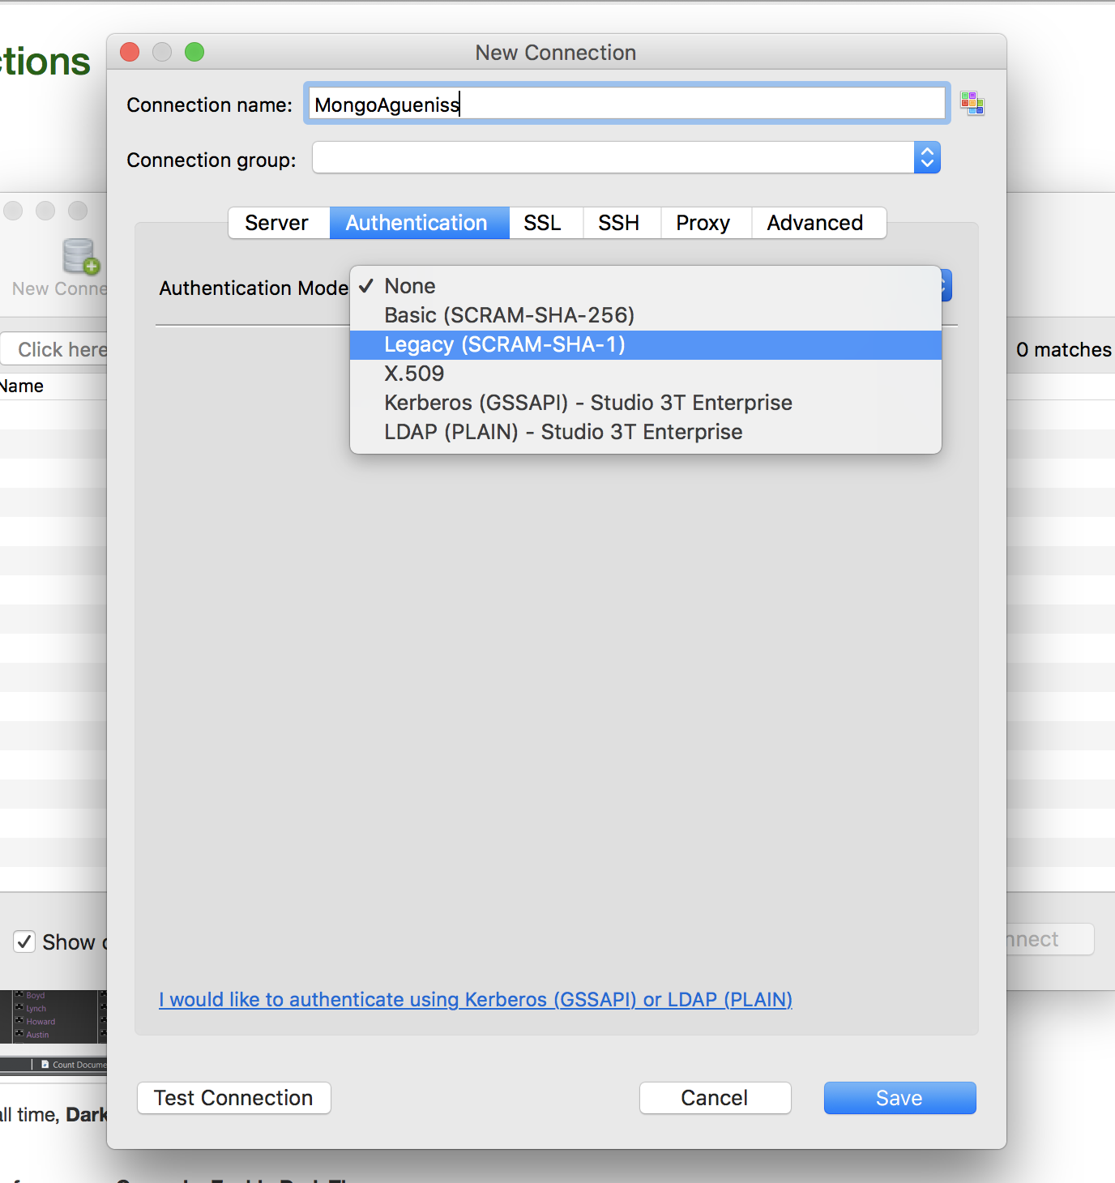

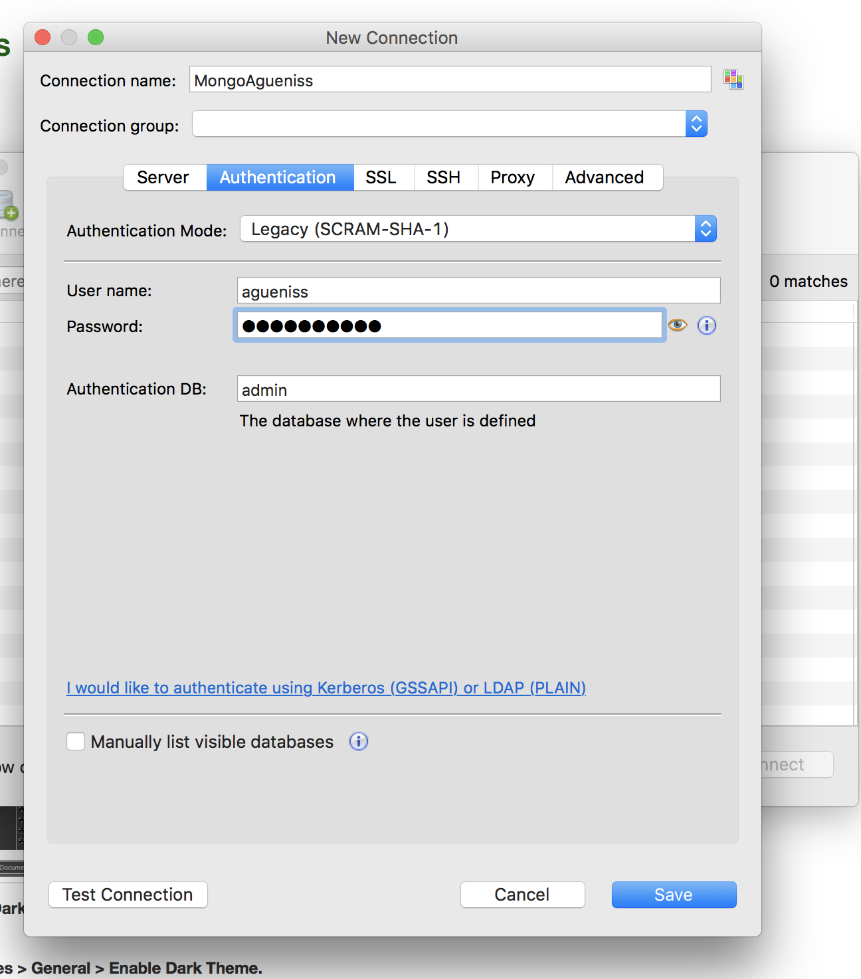

SSL 🡪 Check Use SSL protocol to connect

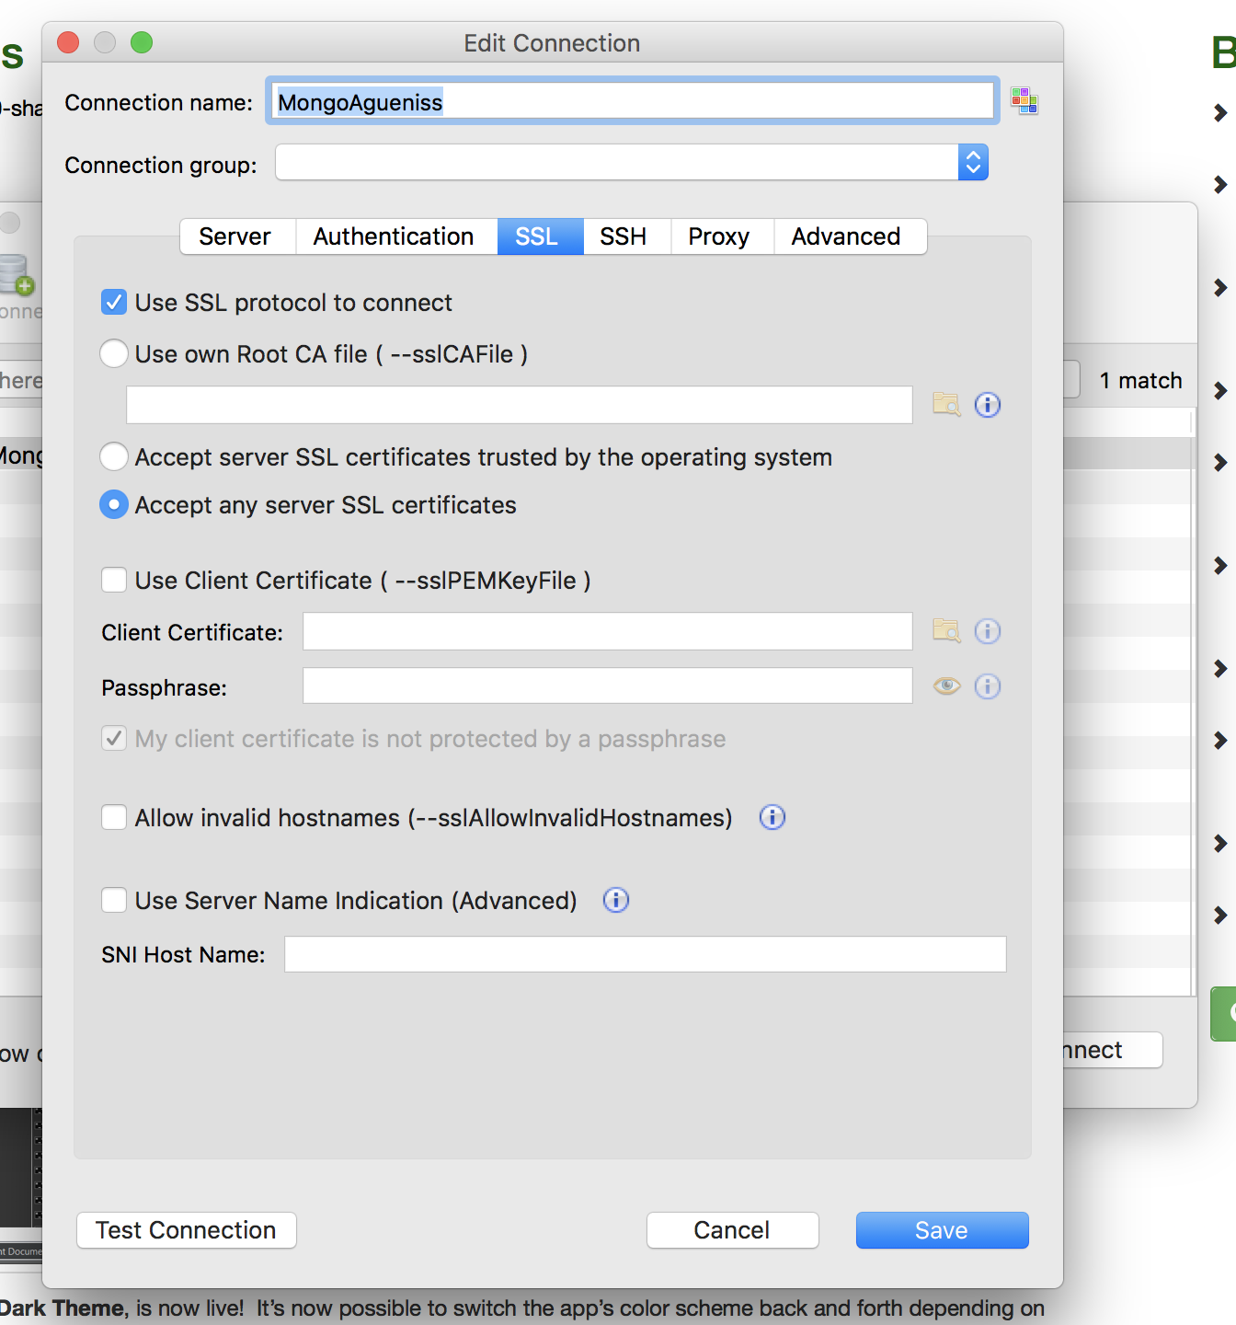

1. Test connection 🡪 Save

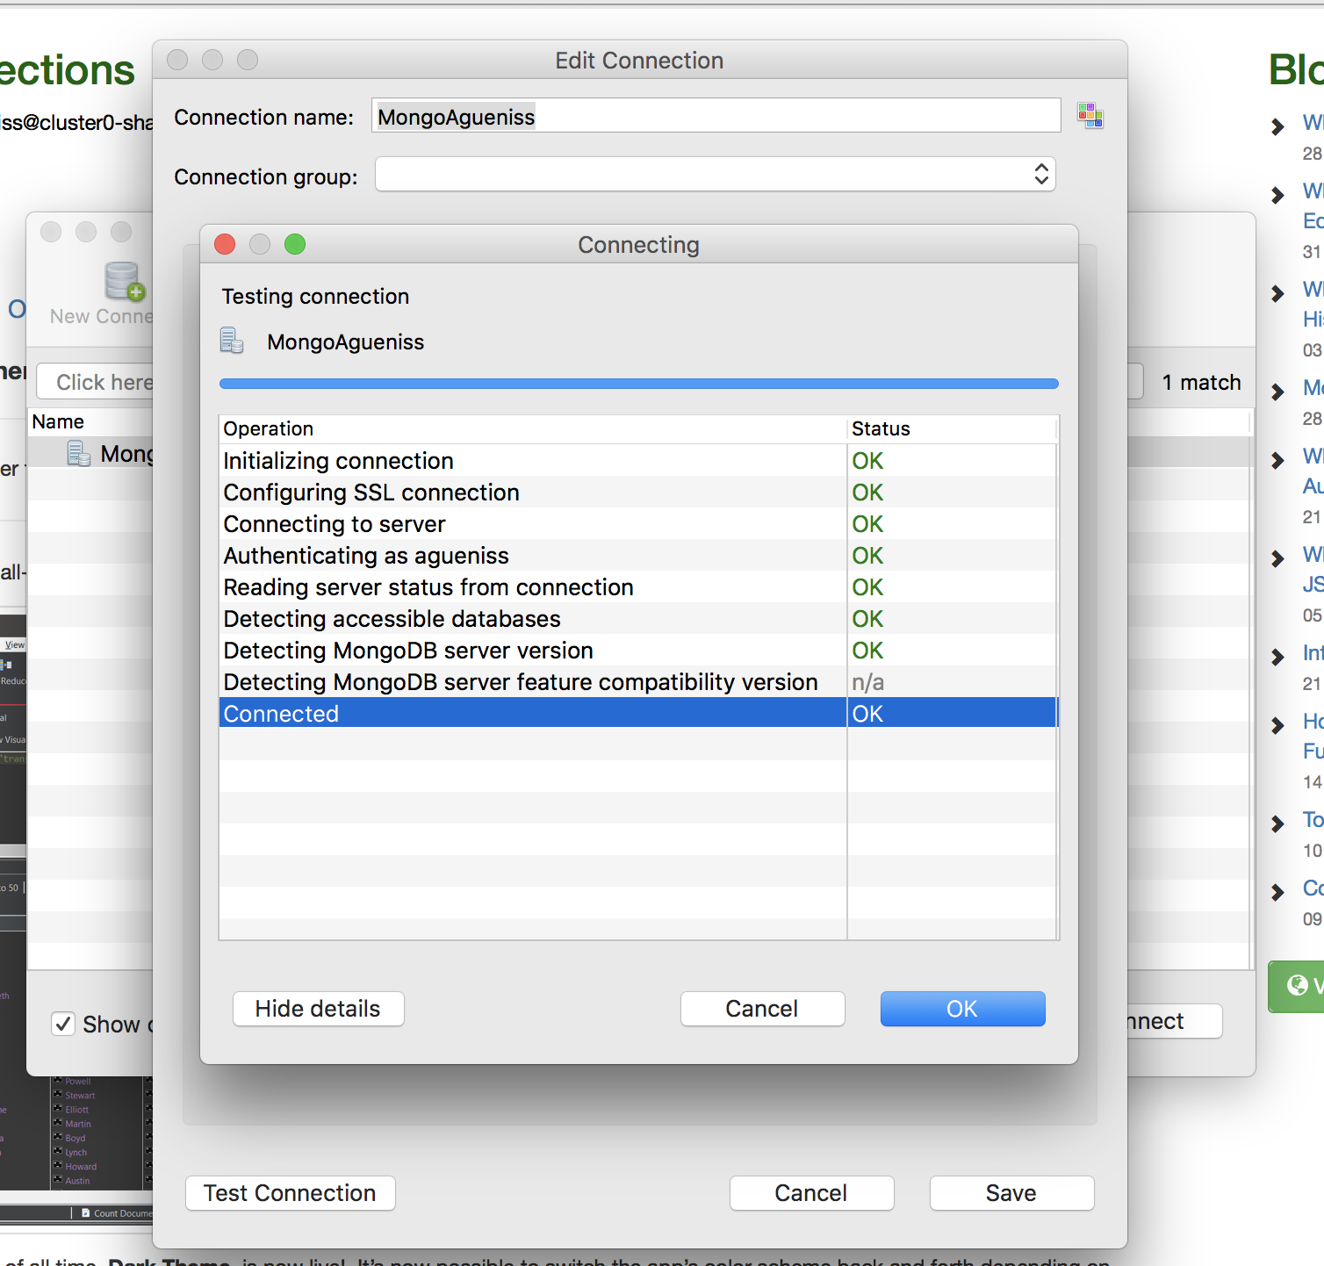

1. Right click on your cluster 🡪 Add Database 🡪 Give database name DATS6102

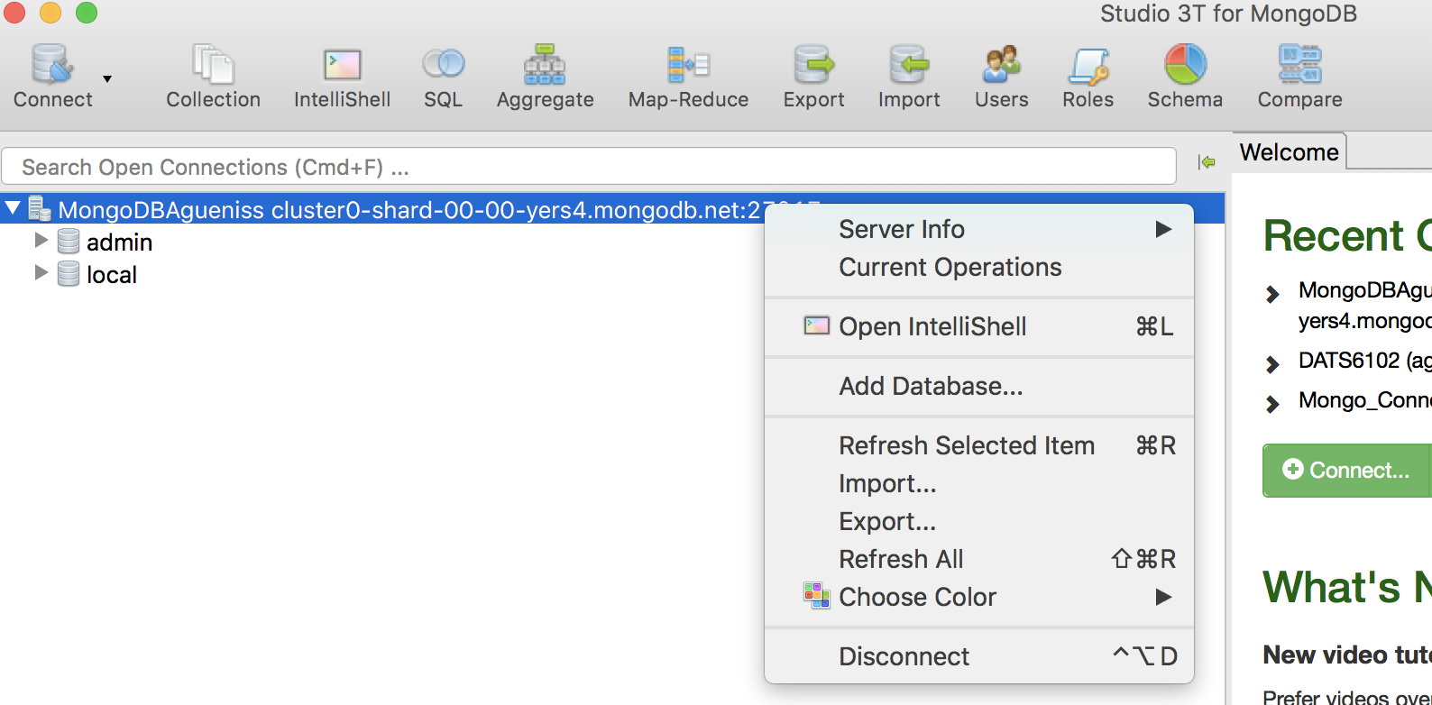

Giving Database Name:

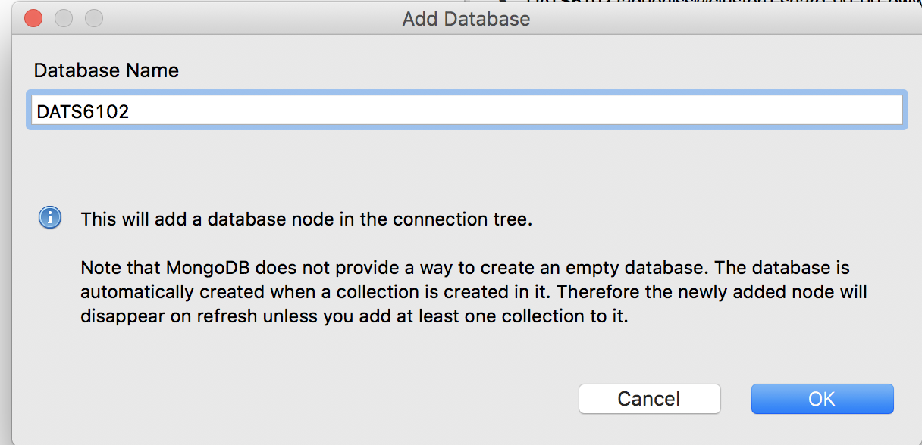

1. Download zips.json and from Blackboard to your local computer. Right-click on your database and click Import Collections

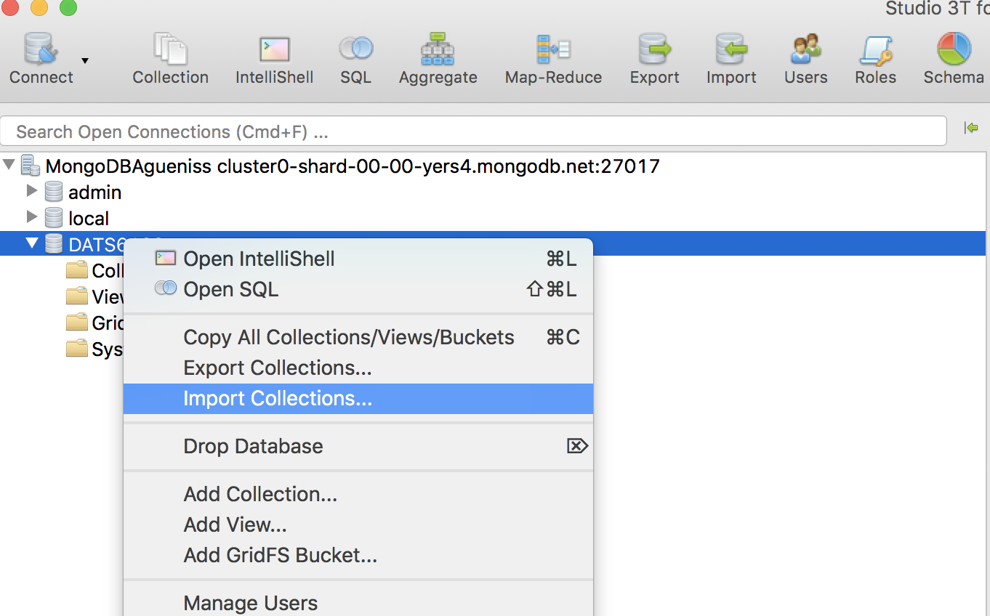

1. Chose JSON format 🡪 Next

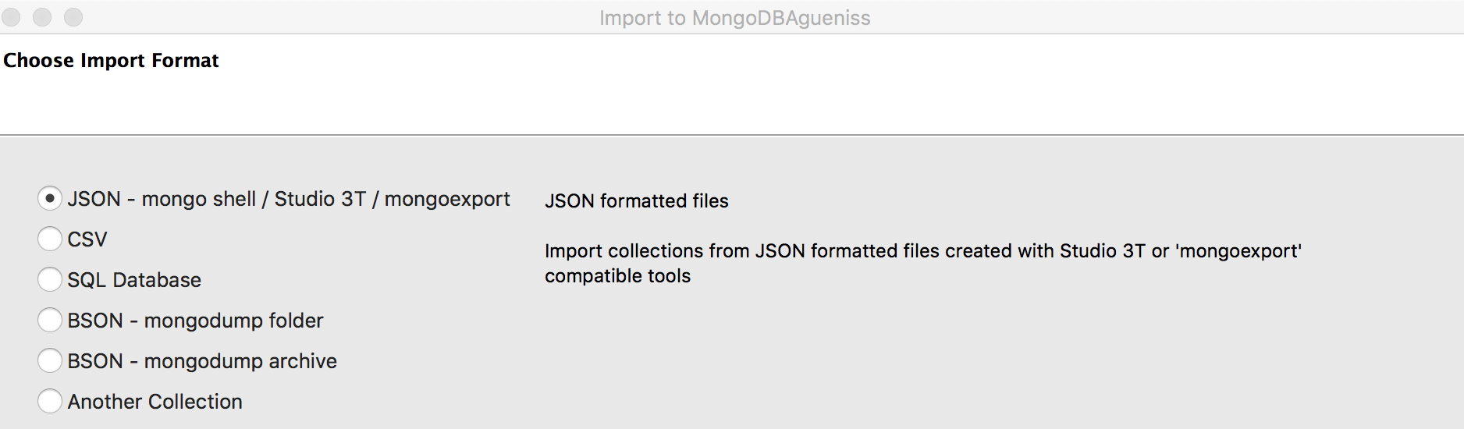

1. Click green plus sign

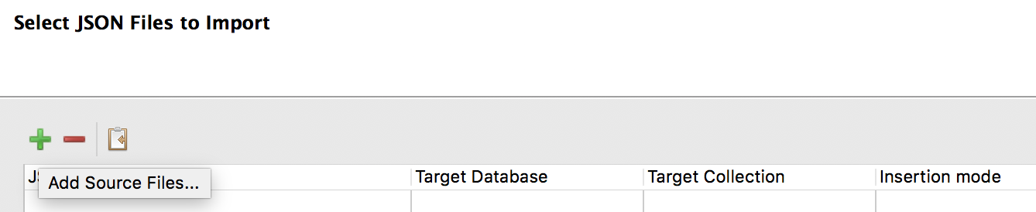

1. Select **zips.json** from your local computer and Execute

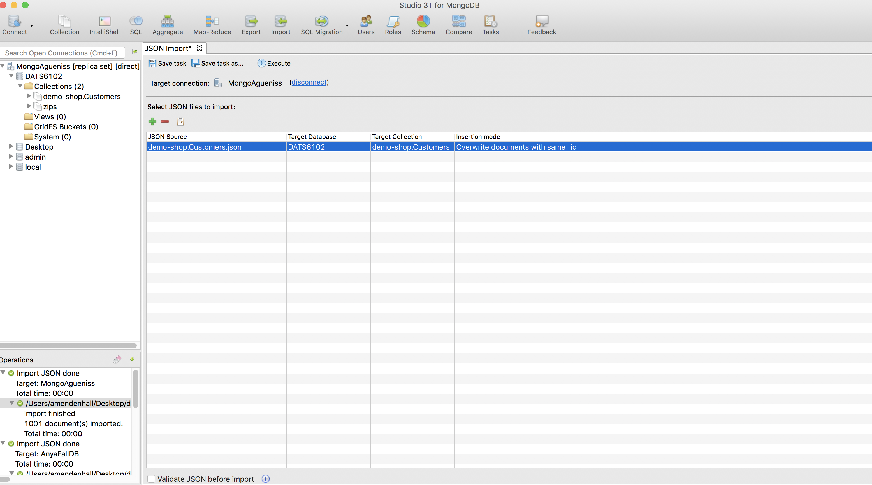

**Part III– Query MongoDB with Studio 3T and SQL**

There are 3 ways to open **SQL Query:**

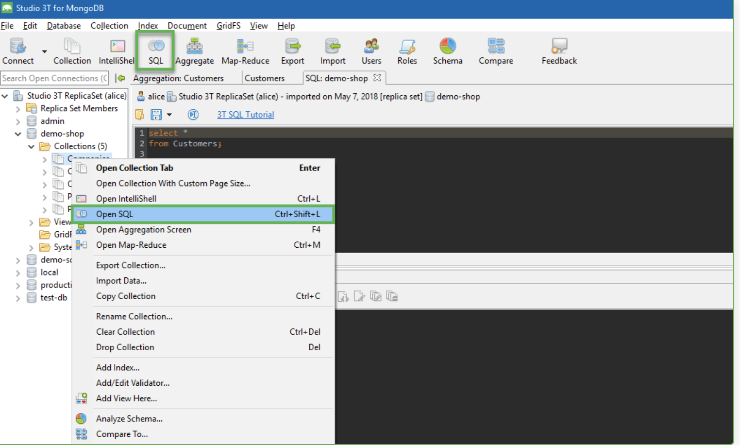

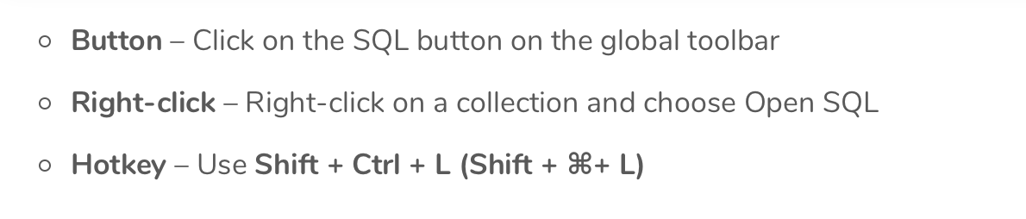

**SQL Query** has two main areas: the Editor where queires are written, and the **Result Tab** where query results are displayed

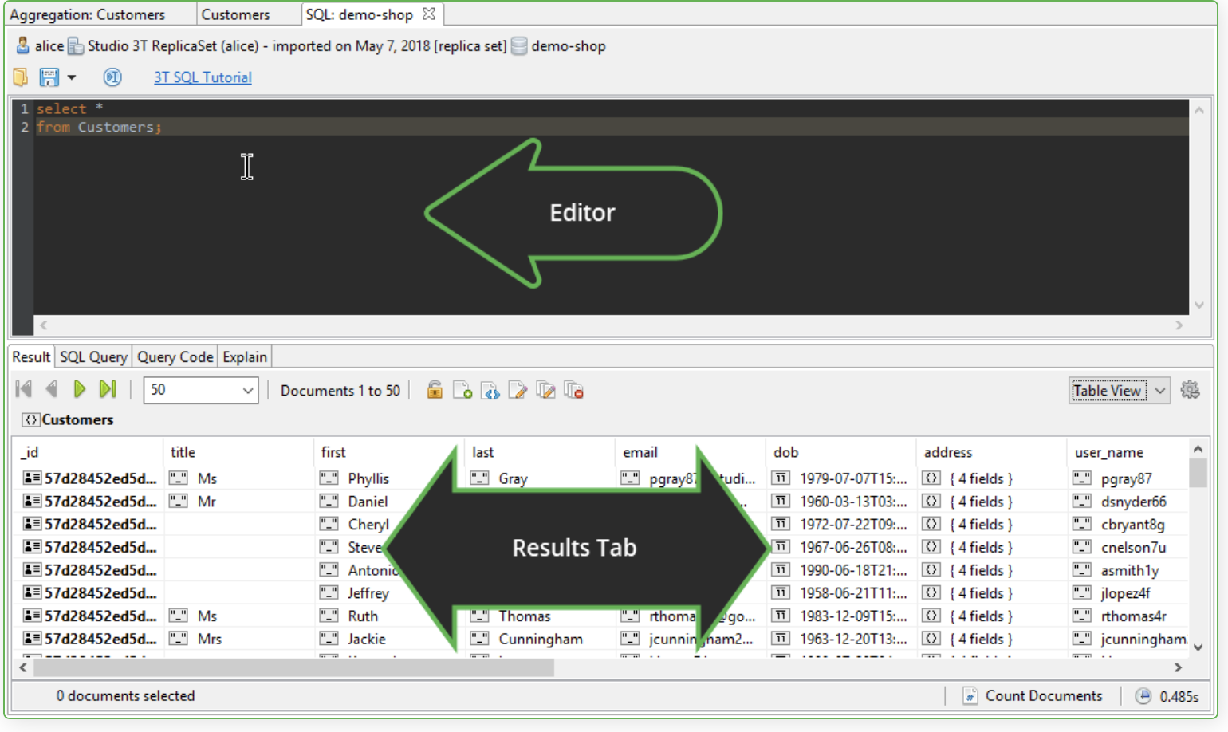

**Execute SQL queries:** 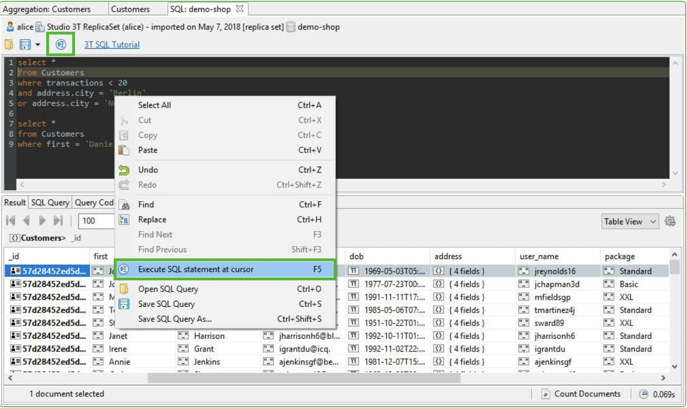

You can execute SQL statement in three ways:

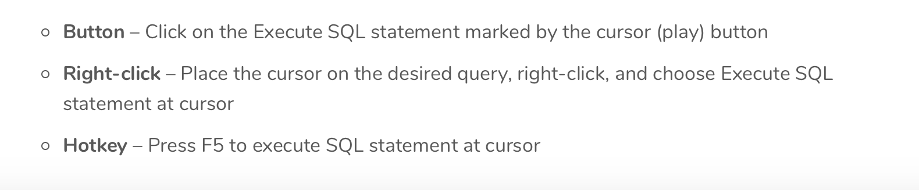

**To view the executed SQL query**

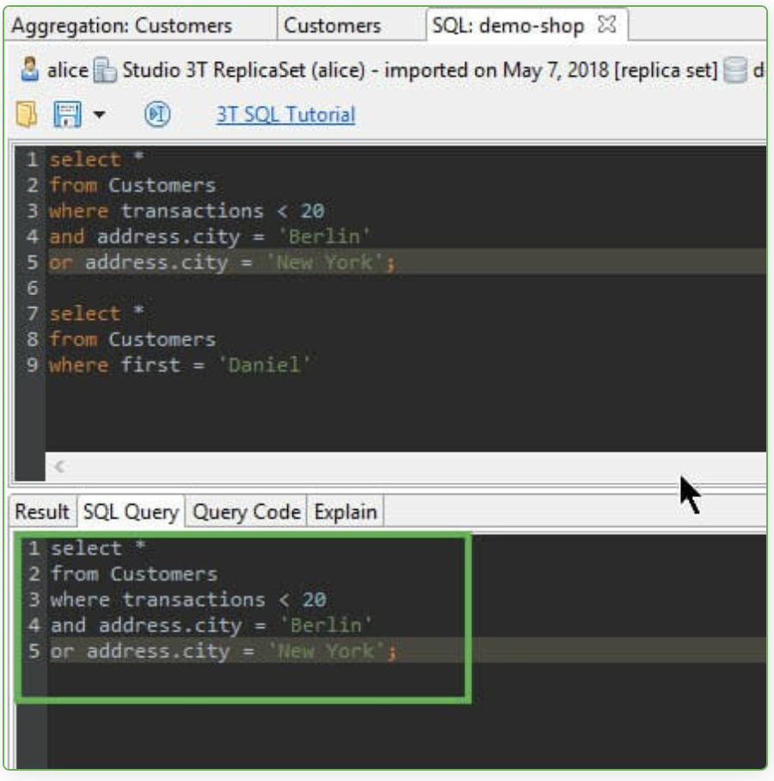

The **Results Tab** offers three different options to view results and edit data:

**Tree View** – allows for users to see the hierarchies in the data. Additionally, data can be edited in-place

**Table View** – sorts data into columns and rows similar to a spreadsheet and enables custom views of embedded fields and sub-fields.

**JSON View** – shows data as JSON documents

**SQL Queries (Zips database):**

1. Count of zip codes

SELECT COUNT(*) FROM zips;

1. List all zip codes and sort them by city name

SELECT * FROM zips ORDER BY city;

1. List the first 5 zip codes in alphabetical order

SELECT * FROM zips ORDER BY city limit 5;

1. List 10 zip codes from row 6 in alphabetical order

SELECT * FROM zips ORDER BY city limit 10 offset 5;

1. List all the zip codes with a population between 1 and 25 inclusive

SELECT city, pop FROM zips WHERE pop between 1 and 25 ORDER BY pop;

1. List all the zip codes in the state of Virginia

SELECT city, pop FROM zips WHERE state = 'VA' ORDER BY city;

1. List all the zip codes in VA that have fewer than 100 people

SELECT city, pop FROM zips WHERE state = 'VA' and pop <100 ORDER BY pop;

1. List all cities and their total population

SELECT city, SUM(pop) FROM zips GROUP BY city ORDER BY SUM(pop) DESC;

1. List all cities in VA that have more 100,000 people

SELECT city, SUM(pop) FROM zips WHERE state = 'VA' GROUP BY city HAVING SUM(pop) > 100000 ORDER BY city;

1. List all cities that starts with M

SELECT * FROM zips WHERE city like 'M%';

1. List all cities that end with “field”

SELECT * FROM zips WHERE city like '%field';

1. List all cities and their average population

SELECT city, AVG(pop) FROM zips GROUP BY city ORDER BY city;

1. List all the zip codes in VA and MA

SELECT * FROM zips WHERE state in ('VA', 'MA');

1. List all the zip codes that start with 2

SELECT * FROM zips WHERE _id like '2%';

You can view how a SQL query is written in MongoDB query syntax:

1. Click on **Query Code** tab
2. Choose **mongo shell**

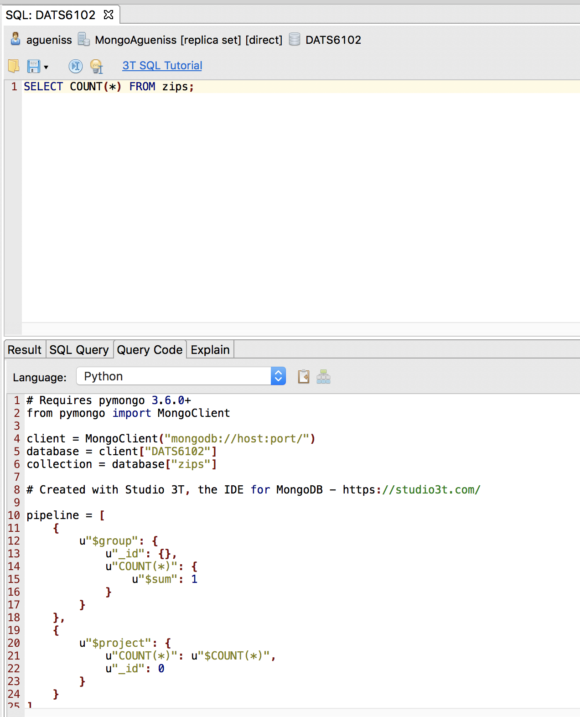

**MongoDB Statements and Queries (move to the IntelliShell):**

**IntelliShell** is the built-in mongo shell in Studio 3T with smart auto-completion of JavaScript standard library functions, shell-specific types and methods, operators, collection names, field names, shell helper commands, and more.

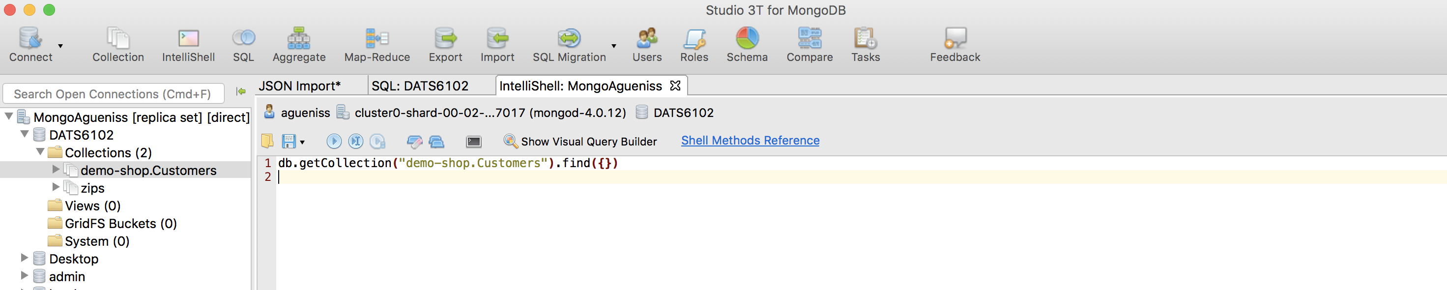

**Important Note: Make sure you are executing statement at cursor and not entire script, or you will get duplicates!!**

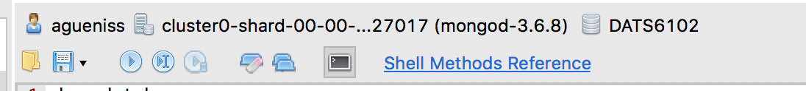

1. Show all the databases

show databases;

1. Create new database classdb. MongoDB **use DATABASE_NAME** is used to create a database. This command will create a new database if it doesn’t exist, otherwise it will return the existing database.

use classdb;

1. Create new collection called “Users”. Click on classdb on the left and execute the following statement. Observe the creation of Users collection:

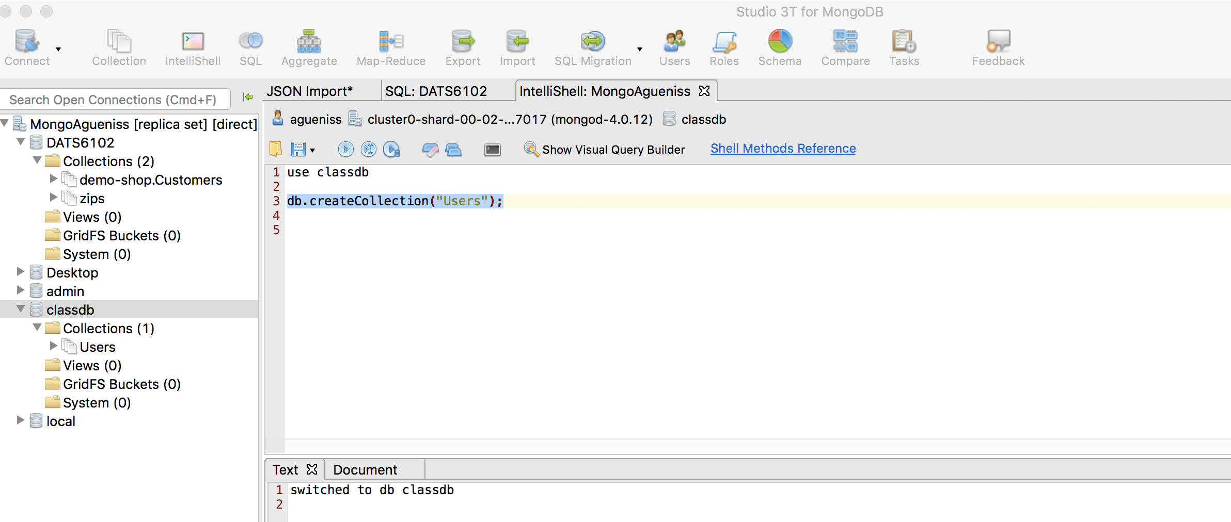

db.createCollection("Users");

1. Add one new user to the “Users” collection. Notice on the right you can switch from JSON to Tree View:

db.Users.insertOne**({**

firstName **:** "Michael"**,**

lastName **:** "Smith"**,**

age **:** 35

**})**

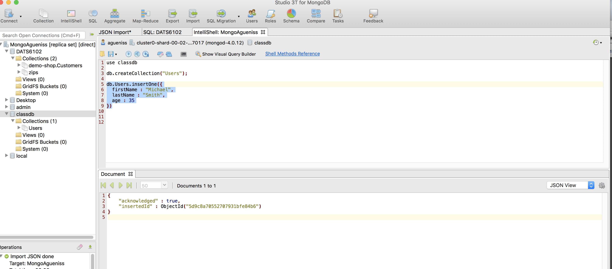

1. Add two more users to the “Users” collection

db.Users.insertMany([

{

firstName : "Tifanny",

lastName : "Reagan",

age : 25

},

{

firstName : "Anthony",

lastName : "Cox",

age : 60

}

]);

1. List all the users

db.Users.find({});

1. Select the user profile with Michael as first name

db.Users.find({

firstName : "Michael"

});

1. Change Michael’s age from 35 to 30

db.Users.updateOne(

{ firstName : "Michael"},

{ $set : {

age : 30

}

});

1. Delete the user with “Cox” as last name

db.Users.deleteOne (

{ lastName : "Cox"

});

Note: if you didn’t create any database, then collections will be stored in supplied by MongoDB default **test** database.

1. Drop classdb database by using **db.dropDatabase()** command:

* First check list of available databases by executing **show dbs** command
* Then:

use classdb

db.dropDatabase()

Show dbs

**SQL Queries (Import demo-shop.Customers database it the same way we did zips):**

1. List all customers living in Berlin

select *

from **[**demo-shop.Customers**]**

where address.city='Berlin'

1. List all customers living in either Berlin or New York with less than 30 transactions

SELECT *

FROM [demo-shop.Customers]

WHERE transactions < 30

AND address.city = 'Berlin'

OR address.city = 'New York';

1. Unique cities represented in the data

SELECT address.city

FROM [demo-shop.Customers]

GROUP BY address.city

ORDER BY address.city;

1. MAX and MIN

SELECT MAX(transactions), MIN(transactions)

FROM [demo-shop.Customers];

1. List customers with transaction between 60 and 100

SELECT *

FROM [demo-shop.Customers]

WHERE transactions between 60 and 100;

1. Show total number of transactions

SELECT SUM(transactions)

FROM [demo-shop.Customers]

1. Switch to IntelliShell click on demo-shop.Customers and get all the records from demo-shop.Customers:

db.getCollection**(**"demo-shop.Customers"**)**.find**({})**